**Project Design Phase-II**

**Technology Stack (Architecture & Stack)**

|  |  |
| --- | --- |
| Date | 29 October 2022 |
| Team ID | PNT2022TMID29094 |
| Project Name | Project - Data Analytics for DHL Logistics Facilities |
| Maximum Marks | 4 Marks |

**Technical Architecture:**

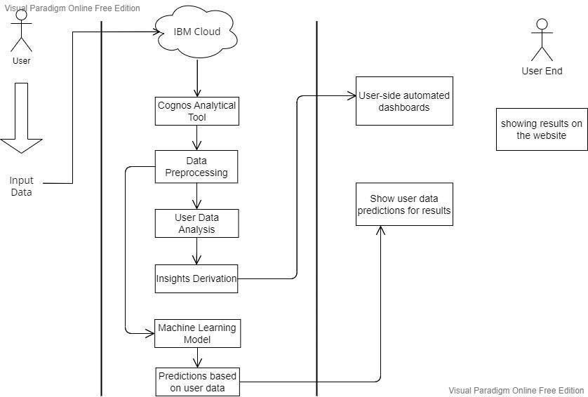

**Table-1: Components & Technologies:**

|  |  |  |  |
| --- | --- | --- | --- |
| **S.No** | **Component** | **Description** | **Technology** |
| 1. | User Interface | User uploads the csv or excel format files into the web pages | HTML, CSS, JavaScript |
| 2. | Application Logic-1 | The user data will pass into the IBM cloud for storing and acts as a data source | IBM cloud |
| 3. | Application Logic-2 | In cloud, data will be fetched by the Cognos analytical tool for data analysis | IBM Cognos analytical tool |
| 4. | Application Logic-3 | The pre-trained Dashboards will be present to perform analysis on the incoming data | IBM Cognos analytical tool |
| 5. | Database | Data will be retrieved from cloud | MySQL |
| 6. | Cloud Database | Database Service on cloud | IBM DB2, IBM Cloud |
| 7. | File Storage | Customer sales data is uploaded in cloud through interface | IBM Block Storage or Other  Storage Service or Local  Filesystem |
| 8. | External API-1 | To perform data analysis on the user data | IBM Cognos Tool |
| 9. | External API-2 | To build the machine learning model for classification | Jupiter Notebook |
| 10. | Machine Learning Model | To do the predictive analysis on the input data | Predictive analysis model, etc. |
| 11. | Infrastructure (Server / Cloud) | Application Deployment on Local System / Cloud Local  Server Configuration: Using the flask Cloud Server Configuration: IBM cloud | Local, Cloud Foundry |

**Table-2: Application Characteristics:**

|  |  |  |  |
| --- | --- | --- | --- |
| **S.No** | **Characteristics** | **Description** | **Technology** |
| 1. | Open-Source Frameworks | List the open-source frameworks used | Technology of Opensource framework |
| 2. | Security Implementations | List all the security / access controls implemented, use of firewalls etc. | e.g., SHA-256, Encryptions, IAM Controls, OWASP etc. |
| 3. | Scalable Architecture | Justify the scalability of architecture (3 – tier, Micro- services) | Technology used |
| 4. | Availability | Justify the availability of application (e.g., use of load balancers, distributed servers etc.) | Technology used |
| 5. | Performance | Design consideration for the performance of the application (number of requests per sec, use of Cache, use of CDN’s) etc. | Technology used |